TEMA 1 - Analysis and Design

Analysis and Design
Analysis: decide what the application should do, in order to:
- Understand the current process in order to model the “real world”, the “domain” (area of expertise that needs to be examined to solve a problem)
- Specify what the new system should do.
- All the entities should be understandable by the user
Design: decide how the application should be done

Software development methodologies
Waterfall model (linear):
- Very simple to use.
- Each phase fully completed before the next.
- Suitable for small projects.
- Fails discovered in testing phase, too late; and very risky with medium or large projects.
Prototyping (iterative):
- Users are actively involved in the development.
- Errors can be detected much earlier.
- Good for systems with complex user interaction.
Agile (incremental= iterative+linear):
- Work incrementally adding piece by piece but each piece is fully finished.
- Easier to test after each increment.
Spiral (incremental):
- More emphasis on risk analysis.
- Risk analysis requires highly specific expertise.

UML VIEWS
Visual notations that are easier to understand than textual languages. With UML we can represent different views of a model.
Regarding the detail level: represent what is relevant.
The detail depends on what we want to transmit:
- detail(analysis) < detail(design) < detail(implementation)

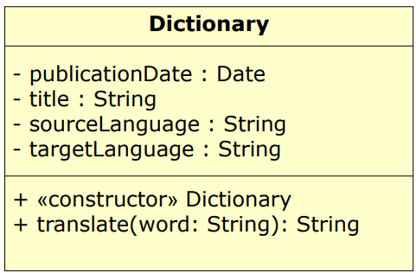
STATIC MODEL: CLASS DIAGRAMS
Visibility:
- Private: -
- Protected: #
- Public: +

Class relationships:
- Association:
- Simple
- Aggregation (whole/part)
- Composition (exclusive whole/part)

- Generalization (inheritance):
- Realization (implementacion)

- Dependency (usage)
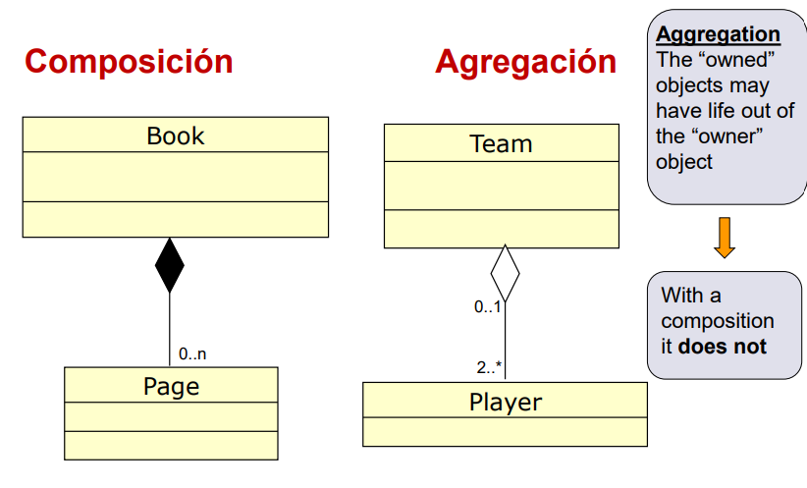
Multiplicity is specified at each end:
- * : 0 or more
- +: at least one
Aggregation is a (sub)type of association and represents whole/part relationships (the class group and its students). It is not restrictive:
- A student could be in more than one group
- A student could exist without a group
- A student could be changed to another group
A composition is a (sub)type of aggregation. It’s also a whole/part relationship and an association (A book and its pages, a tree and its leaves). Composition is more restrictive, it has:
- Strong life cycle dependency: if the whole is destroyed, its parts are also destroyed. If you fire a book all the pages will fire
- Strong ownership: you cannot move a page from one book to another (the same with leaves)
- Strong dependency: A leaf cannot live without a tree
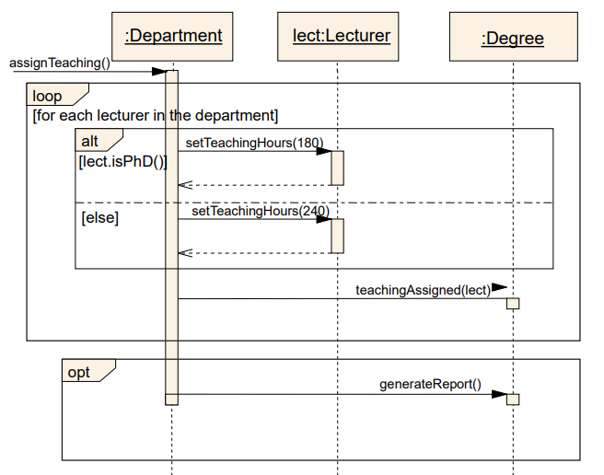
DYNAMIC MODEL: SEQUENCE DIAGRAMS
Models interactions between objects (not classes) and emphasizes the temporal ordering of messages. Associations between objects are not shown

DYNAMIC MODEL: STATE MACHINES
Dynamic behavior of part of the system. It Comprises states and transitions
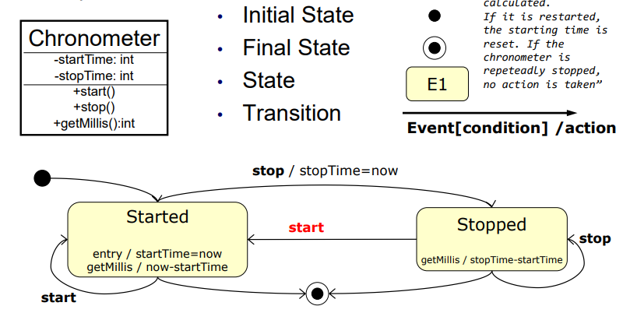

DYNAMIC MODEL: ACTIVITY DIAGRAMS
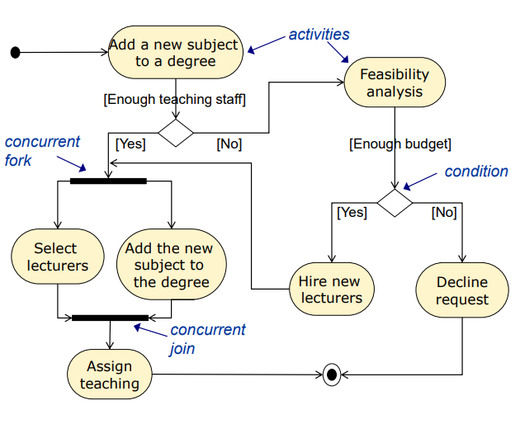
Shows the steps of algorithms, workflows, multi-threading scenarios… Each step is referred to as an activity. It is not appropriate to model collaboration between objects or the dynamic behavior of class instances.

CLASS DESIGN
A good class design offers good code maintainability:
- Easy to adapt (adaptive): We can easily adapt the application to new environments
- Easy to extend (perfective): We can easily add new functionality when needed
- Easy to debug (corrective): We can easily find and solve errors
- Robust (preventive): The application can cope with errors during execution or can continue to operate despite any errors produced
Two terms are central when talking about the quality of class design: COUPLING AND COHESION
COUPLING (HAVE TO REDUCE IT AS MUCH AS POSSIBLE)
Refers to the interconnectedness of classes. The degree of coupling indicates how tightly these classes are connected. It can be also applied to methods and packages.
The degree of coupling determines how hard it is to make changes in an application. We SEARCH for a low degree of coupling, or loose coupling (opposite to tight coupling).
Reduce the public part to the minimum. Do not use public fields (except final) because it makes the code tightly coupled.
COHESION
Relates to the number and diversity of tasks a class is responsible for. It can be also applied to methods and packages.
Each class should represent one kind of entity, then, it is said to have high cohesion (it improves its reutilization).
Code duplication makes the code less maintainable, and we have to AVOID IT! Make your code high cohesive!
Good designs are loosely coupled:
- Classes should reduce their interfaces to the minimum
- Do not pass too many parameters (to methods)
- Reduce the number of public classes in a package
Good designs are highly cohesive:
- Methods should implement a single operation
- A class should represent a single entity (concept)
- Classes in a package should be related
Responsibility-driven design (RDD) is another design principle to reduce it (and obtain high cohesion). RDD expresses the idea that each class should be responsible for handling its own data (Place new methods in those classes that provide the data they require).

Refactoring is the activity of restructuring existing classes and methods to improve non-functional characteristics of software. In the lifetime of an application, functionality is gradually added.
Refactoring is the re-thinking and re-designing of class and method structures
- Classes can be split into two
- Methods are divided into two or more
- The objective is loose coupling and high cohesion
When the code is refactored, errors are likely to be introduced. Therefore, it is important to have a set of tests

CONCLUSION
It is important to achieve good software maintainability and quality
Coupling and cohesion are the basics of good software design (Loose coupling and High cohesion)
Coding recommendations are also important: names of identifiers, comments, legibility…
Software refactoring and testing are two important tools to build quality software
Refactoring and testing are also applied during the program lifetime: You build, test, refactor, test the refactorization, build, test, etc

TEMA 2 - Inheritance
We have seen how code duplication involves low maintainability. CD and DVD are very similar!

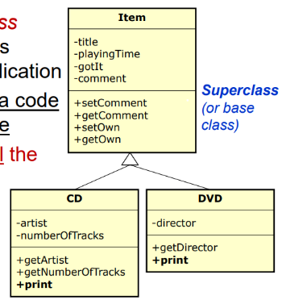
SUPERCLASS
The extract superclass refactoring solves this problem of code duplication. It uses Inheritance, a code reutilization technique. Subclasses inherit all the members of their superclass.
Subclasses inherit all the members of their superclass
Private members can only be accessed in their own class. Public members are visible to all classes everywhere. Package members are visible only within their own package. With inheritance: Protected members can only be accessed within their own package and, in addition, by a subclass of their class in any other package
Coupling is not only between client and provider classes. We should also consider derived (sub) classes. Therefore, attributes (fields) should be private!

INHERITANCE AND CONSTRUCTORS
- Constructors are not inherited
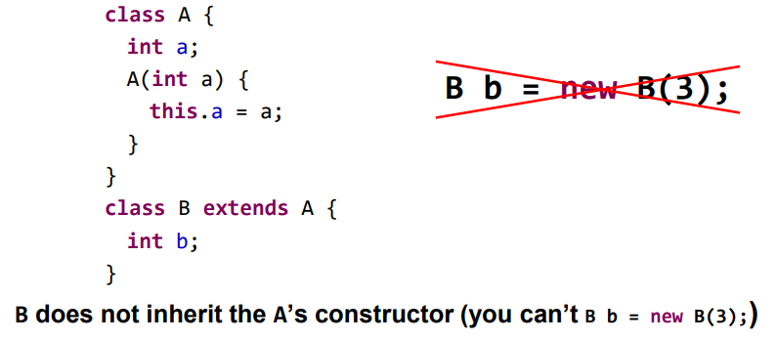
- Derived constructors must invoke to their base constructor (done by invoking the super method, and in the first sentence of the son constructor)
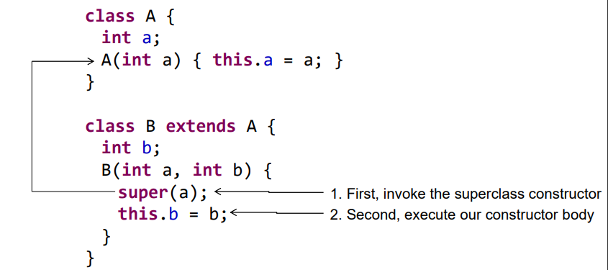
- If you don’t provide any constructor to a class the compiler automatically inserts a default empty constructor without parameters
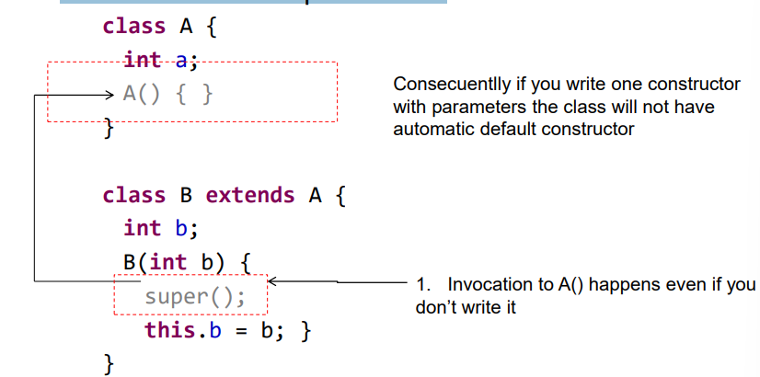

- The default base constructor invocation is super(), the base constructor without parameters
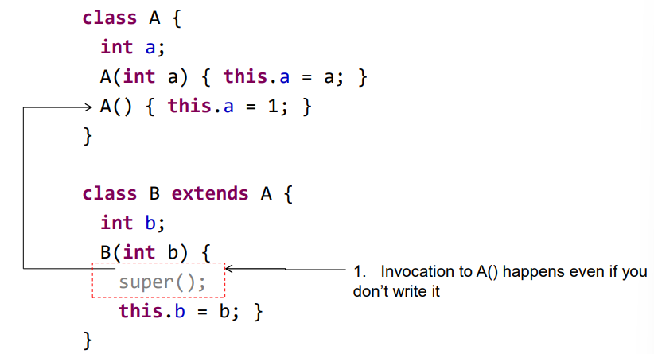

BENEFITS OF INHERITANCE
- Mechanism for avoiding code duplication: Superclass code can be used by all child classes
- Mechanism for code reuse: If an algorithm works with a certain class type, it will also work with its subclasses without changes
- Improves maintainability: easier to isolate and correct errors and to add new features by creating new subclases
- Improves extensibility of existing classes: Add new code that uses existing one and Pick the existing code and change it to meet new requirements

GENERALIZATION / POLYMORPHISM
Item is a generalization of DVD and CD. It means that an Item reference can point to:
- An Item object
- A CD object
- A DVD object
- Future subclasses of Item
This feature is called Polymorphism (an Item reference is said to be polymorphic). In Java, inheritance involves polymorphism.
Polymorphism is an essential tool to create maintainable software.

SUBTYPES
In Java, for instance:
- byte ≤ short ≤ int ≤ long (BYTE IS A SUBTYPE OF SHORT OR A BYTE PROMOTES TO A SHORT)
- char ≤ int
- float ≤ double
With Polymorphism, a subclass is a subtype of a superclass (subclass ≤ superclass, CD ≤ Item, DVD ≤ Item)
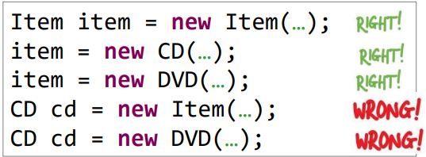
Subtyping involves Substitution, which can occur in assignments and parameter passing (it helps to create maintainable code):

In the inheritance tree, the promotion is performed upwards. Since all the members in CD and DVD are also members of Item, it is safe to perform the substitution. Therefore, up-casting is correct.
However, the following code is rejected by the compiler:
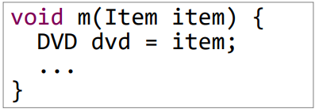
This is wrong because the item variable could be a DVD, but it could also be a CD, or a VideoGame… And, for example, it would be meaningless to pass the getDirector() message to a cd object.
Therefore, implicit down-casting is not allowed .
Is it possible to down-cast with a cast?
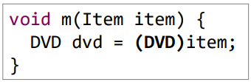
In that case, an error (exception) would be thrown at runtime:
Can you downcast? YES
Can you break the program execution if you downcast to the wrong type? YES
Does the same happen with upcasting? NO, it’s safe. If the conversion is required, use the instanceof operator to make your code safer
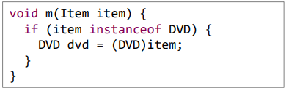

OBJECT AND BUILT-IN TYPES
Is it possible to collect any object? In order to do this, Java creates every class as a subclass of one superclass: Object. Therefore, an ArrayList can collect any object. Every class inherits from Object. What happens with built-in (primitive) types? (boolean, char, byte, short, int, long, float and double) They do not inherit from Object!
- Boxing: wraps a primitive value in an object.
- Unboxing: extracts the primitive value from object.
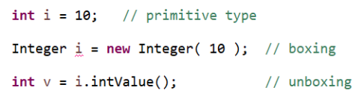
Due to autoboxing, a built-in type variable is automatically converted to an object (and vice versa) To which object (class)?
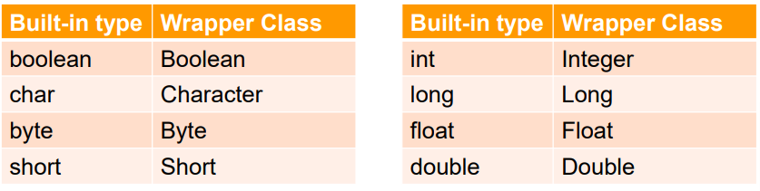
Autoboxing comprises Boxing: A built-in type is automatically converted to a wrapper object, and Unboxing: A wrapper class is automatically converted to a built-in type

TEMA 3 – IMPROVE WITH INHERITANCE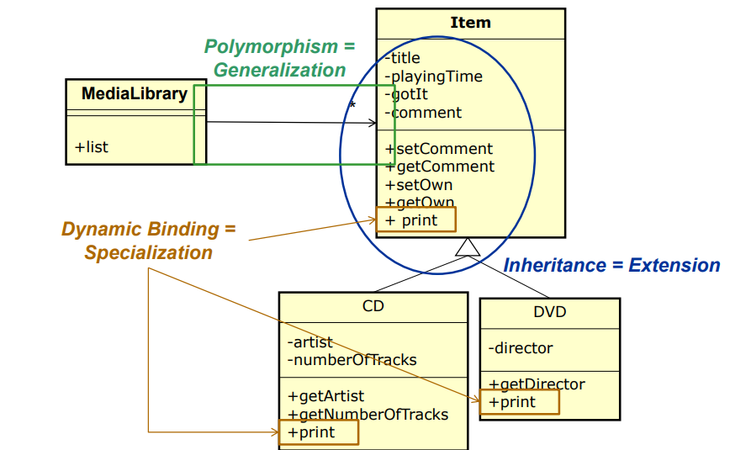
With Polymorphism , references have more than one type.

DYNAMIC AND STATIC TYPE
The static type of a reference is its declared type and the dynamic type is the is the type of the object the
reference is pointing to, in a specific point of execution
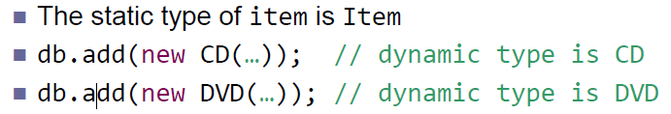

DYNAMIC BINDING
The actual method to be called is (fortunately), the one in its dynamic type. This mechanism is called Dynamic Binding. If we want to avoid dynamic binding , the (superclass) method should be qualified as final.
The print method in DVD and CD is said to Override the print method of Item (it is also said to be polymorphic). Method overriding (dynamic binding) requires methods to havethe exact signature.
Dynamic binding and method overriding is a mechanism for specialization. The print message is specialized in the derived classes
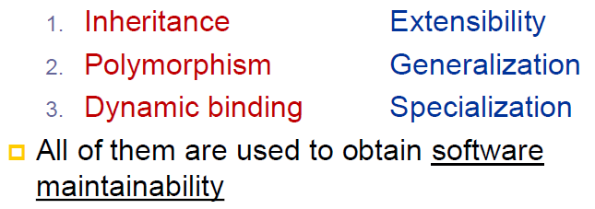 To avoid code duplication, we can use the super reference to call the methods of the super class and reuse them
TEMA 4 – FUTURE ABSTRACTION TECHNIQUES

ABSTRACT METHODS
When we use polymorphism, it is very common that: we must declare a method and we do not have a coherent implementation.
If we add abstract methods, that class must be declared as abstract. It is a class whose purpose is to serve as a superclass for other classes, either for generalization (polymorphism) or for code reuse (inheritance).
It is not possible to create instances of abstract classes.
Abstract classes force subclasses to override those methods declared as abstract (otherwise, subclasses would be abstract too). In Java, it is possible to declare an abstract class without any abstract method.

EQUALITY
In Java, two kinds of equality are distinguished:
- Object identity equality: two object references point to the same object. For this, the == operator is used. It works out when two objects are exactly the same object. ( Person p = new Person(); Person pb; ▪ pb = p; ▪ p == pb; // is true )
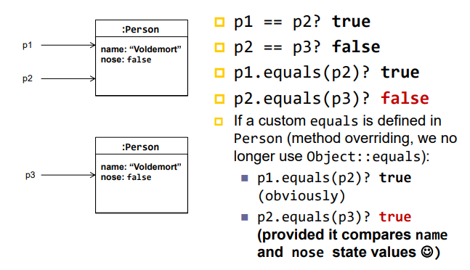
- Object state equality: two separate objects happen to represent the same entity (thing of the reality). For this, the equals method in Object is used. It shows when two objects represent the same entity.

INTERFACES
An interface is the set of messages a class provides to their clients (public). In Java, this concept is offered as a type. Therefore, a Java interface is a set of method declarations, without any implementation. All their methods are abstract and public (the keyword is not needed). They cannot have constructors and only public static final attributes are allowed.
Multiple generalization is often required π Since Java does not provide multiple inheritance, interfaces are used instead. Dynamic binding is heavily employed in interfaces because all the methods in an interface must be overridden, and it is used for multiple polymorphism (subtyping) ⇒ A new dimension is added.
A common question in Java is when to use abstract classes or interfaces. Since Java does not provide multiple inheritance. Only use abstract classes when you want to inherit implementations (methods or attributes). If you have a choice, interfaces are usually preferable.
Interfaces reduce the coupling to the minimum and tend to be much more stable than implementations.

